[1.5,0.5,1]

1 run...

Downloading: 100%

411/411 [00:00<00:00, 14.6kB/s]

Downloading: 100%

263M/263M [00:06<00:00, 44.3MB/s]

training 1 epoch...

71.61257243156433 seconds used......

1 training finished! average train loss: 1.12152080592655

evaluating...

Confusion matrix, without normalization

[[124 0 0]

[164 0 0]

[865 0 0]]

Normalized confusion matrix

[[1. 0. 0.]

[1. 0. 0.]

[1. 0. 0.]]

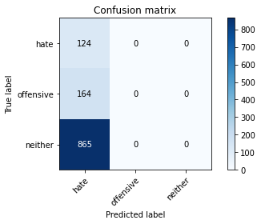

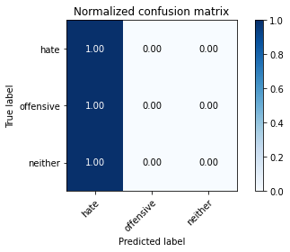

/opt/conda/lib/python3.7/site-packages/sklearn/metrics/_classification.py:1245: UndefinedMetricWarning: Precision and F-score are ill-defined and being set to 0.0 in labels with no predicted samples. Use `zero_division` parameter to control this behavior.

_warn_prf(average, modifier, msg_start, len(result))

/opt/conda/lib/python3.7/site-packages/sklearn/metrics/_classification.py:1245: UndefinedMetricWarning: Precision and F-score are ill-defined and being set to 0.0 in labels with no predicted samples. Use `zero_division` parameter to control this behavior.

_warn_prf(average, modifier, msg_start, len(result))

/opt/conda/lib/python3.7/site-packages/sklearn/metrics/_classification.py:1245: UndefinedMetricWarning: Precision and F-score are ill-defined and being set to 0.0 in labels with no predicted samples. Use `zero_division` parameter to control this behavior.

_warn_prf(average, modifier, msg_start, len(result))

precision recall f1-score support

hate 0.11 1.00 0.19 124

offensive 0.00 0.00 0.00 164

neither 0.00 0.00 0.00 865

accuracy 0.11 1153

macro avg 0.04 0.33 0.06 1153

weighted avg 0.01 0.11 0.02 1153

average eval_loss: 1.0541408452494392, accuracy: 0.10754553339115351

training 2 epoch...

70.81249690055847 seconds used......

2 training finished! average train loss: 1.0275403651453199

evaluating...

Confusion matrix, without normalization

[[ 0 0 124]

[ 0 0 164]

[ 0 0 865]]

Normalized confusion matrix

[[0. 0. 1.]

[0. 0. 1.]

[0. 0. 1.]]

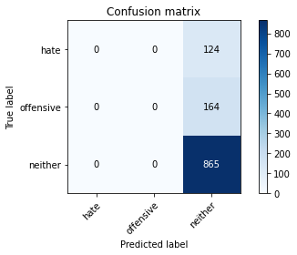

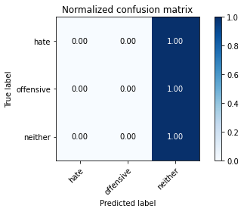

/opt/conda/lib/python3.7/site-packages/sklearn/metrics/_classification.py:1245: UndefinedMetricWarning: Precision and F-score are ill-defined and being set to 0.0 in labels with no predicted samples. Use `zero_division` parameter to control this behavior.

_warn_prf(average, modifier, msg_start, len(result))

/opt/conda/lib/python3.7/site-packages/sklearn/metrics/_classification.py:1245: UndefinedMetricWarning: Precision and F-score are ill-defined and being set to 0.0 in labels with no predicted samples. Use `zero_division` parameter to control this behavior.

_warn_prf(average, modifier, msg_start, len(result))

/opt/conda/lib/python3.7/site-packages/sklearn/metrics/_classification.py:1245: UndefinedMetricWarning: Precision and F-score are ill-defined and being set to 0.0 in labels with no predicted samples. Use `zero_division` parameter to control this behavior.

_warn_prf(average, modifier, msg_start, len(result))

precision recall f1-score support

hate 0.00 0.00 0.00 124

offensive 0.00 0.00 0.00 164

neither 0.75 1.00 0.86 865

accuracy 0.75 1153

macro avg 0.25 0.33 0.29 1153

weighted avg 0.56 0.75 0.64 1153

average eval_loss: 0.9069508509389286, accuracy: 0.7502168256721596

training 3 epoch...

70.76739597320557 seconds used......

3 training finished! average train loss: 1.0277351541888147

evaluating...

Confusion matrix, without normalization

[[124 0 0]

[164 0 0]

[865 0 0]]

Normalized confusion matrix

[[1. 0. 0.]

[1. 0. 0.]

[1. 0. 0.]]





/opt/conda/lib/python3.7/site-packages/sklearn/metrics/_classification.py:1245: UndefinedMetricWarning: Precision and F-score are ill-defined and being set to 0.0 in labels with no predicted samples. Use `zero_division` parameter to control this behavior.

_warn_prf(average, modifier, msg_start, len(result))

/opt/conda/lib/python3.7/site-packages/sklearn/metrics/_classification.py:1245: UndefinedMetricWarning: Precision and F-score are ill-defined and being set to 0.0 in labels with no predicted samples. Use `zero_division` parameter to control this behavior.

_warn_prf(average, modifier, msg_start, len(result))

/opt/conda/lib/python3.7/site-packages/sklearn/metrics/_classification.py:1245: UndefinedMetricWarning: Precision and F-score are ill-defined and being set to 0.0 in labels with no predicted samples. Use `zero_division` parameter to control this behavior.

_warn_prf(average, modifier, msg_start, len(result))

precision recall f1-score support

hate 0.11 1.00 0.19 124

offensive 0.00 0.00 0.00 164

neither 0.00 0.00 0.00 865

accuracy 0.11 1153

macro avg 0.04 0.33 0.06 1153

weighted avg 0.01 0.11 0.02 1153

average eval_loss: 1.1432264889108723, accuracy: 0.10754553339115351

training 4 epoch...

70.77167248725891 seconds used......

4 training finished! average train loss: 1.0271120649718104

evaluating...

Confusion matrix, without normalization

[[124 0 0]

[164 0 0]

[865 0 0]]

Normalized confusion matrix

[[1. 0. 0.]

[1. 0. 0.]

[1. 0. 0.]]





/opt/conda/lib/python3.7/site-packages/sklearn/metrics/_classification.py:1245: UndefinedMetricWarning: Precision and F-score are ill-defined and being set to 0.0 in labels with no predicted samples. Use `zero_division` parameter to control this behavior.

_warn_prf(average, modifier, msg_start, len(result))

/opt/conda/lib/python3.7/site-packages/sklearn/metrics/_classification.py:1245: UndefinedMetricWarning: Precision and F-score are ill-defined and being set to 0.0 in labels with no predicted samples. Use `zero_division` parameter to control this behavior.

_warn_prf(average, modifier, msg_start, len(result))

/opt/conda/lib/python3.7/site-packages/sklearn/metrics/_classification.py:1245: UndefinedMetricWarning: Precision and F-score are ill-defined and being set to 0.0 in labels with no predicted samples. Use `zero_division` parameter to control this behavior.

_warn_prf(average, modifier, msg_start, len(result))

precision recall f1-score support

hate 0.11 1.00 0.19 124

offensive 0.00 0.00 0.00 164

neither 0.00 0.00 0.00 865

accuracy 0.11 1153

macro avg 0.04 0.33 0.06 1153

weighted avg 0.01 0.11 0.02 1153

average eval_loss: 1.1782883991455209, accuracy: 0.10754553339115351

training 5 epoch...

70.79928660392761 seconds used......

5 training finished! average train loss: 1.0250820684291067

evaluating...

Confusion matrix, without normalization

[[124 0 0]

[164 0 0]

[865 0 0]]

Normalized confusion matrix

[[1. 0. 0.]

[1. 0. 0.]

[1. 0. 0.]]





/opt/conda/lib/python3.7/site-packages/sklearn/metrics/_classification.py:1245: UndefinedMetricWarning: Precision and F-score are ill-defined and being set to 0.0 in labels with no predicted samples. Use `zero_division` parameter to control this behavior.

_warn_prf(average, modifier, msg_start, len(result))

/opt/conda/lib/python3.7/site-packages/sklearn/metrics/_classification.py:1245: UndefinedMetricWarning: Precision and F-score are ill-defined and being set to 0.0 in labels with no predicted samples. Use `zero_division` parameter to control this behavior.

_warn_prf(average, modifier, msg_start, len(result))

/opt/conda/lib/python3.7/site-packages/sklearn/metrics/_classification.py:1245: UndefinedMetricWarning: Precision and F-score are ill-defined and being set to 0.0 in labels with no predicted samples. Use `zero_division` parameter to control this behavior.

_warn_prf(average, modifier, msg_start, len(result))

precision recall f1-score support

hate 0.11 1.00 0.19 124

offensive 0.00 0.00 0.00 164

neither 0.00 0.00 0.00 865

accuracy 0.11 1153

macro avg 0.04 0.33 0.06 1153

weighted avg 0.01 0.11 0.02 1153

average eval_loss: 1.0546171963214874, accuracy: 0.10754553339115351